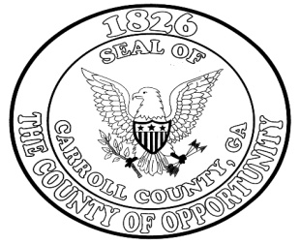

**Age Affidavit – Exemption for 70 +**

**Carroll County, Georgia**

**Date of Jury Service: ______________________**

Juror Name (Print Name)___________________________________________________________

Juror Number: ___________________ Juror Telephone No: _____________________________

Juror Address: ___________________________________________________________

___________________________________________________________

I, ____________________________, do hereby request the Superior/State Court of Carroll County permanently remove my name from the list of eligible Trial and Grand Jurors for Carroll County, Georgia.

I hereby affirm that:

My date of birth is: ____/_____/_______. My age is _______ and I currently reside in Carroll County, GA.

**Signature**: ____________________________________________________

**(Note: Affidavit must be signed in front of a Notary)**

Subscribed and sworn before me this ____________

Day of __________________________, 2_________.

___________________________________________

Notary Public

**Upon completion, return this Affidavit to:**

**Jury Liaison Officer**

**Superior/State Court of Carroll County**

**311 Newnan Street**

**Carrollton, GA 30117**

**Or Fax to: 770-214-3584**